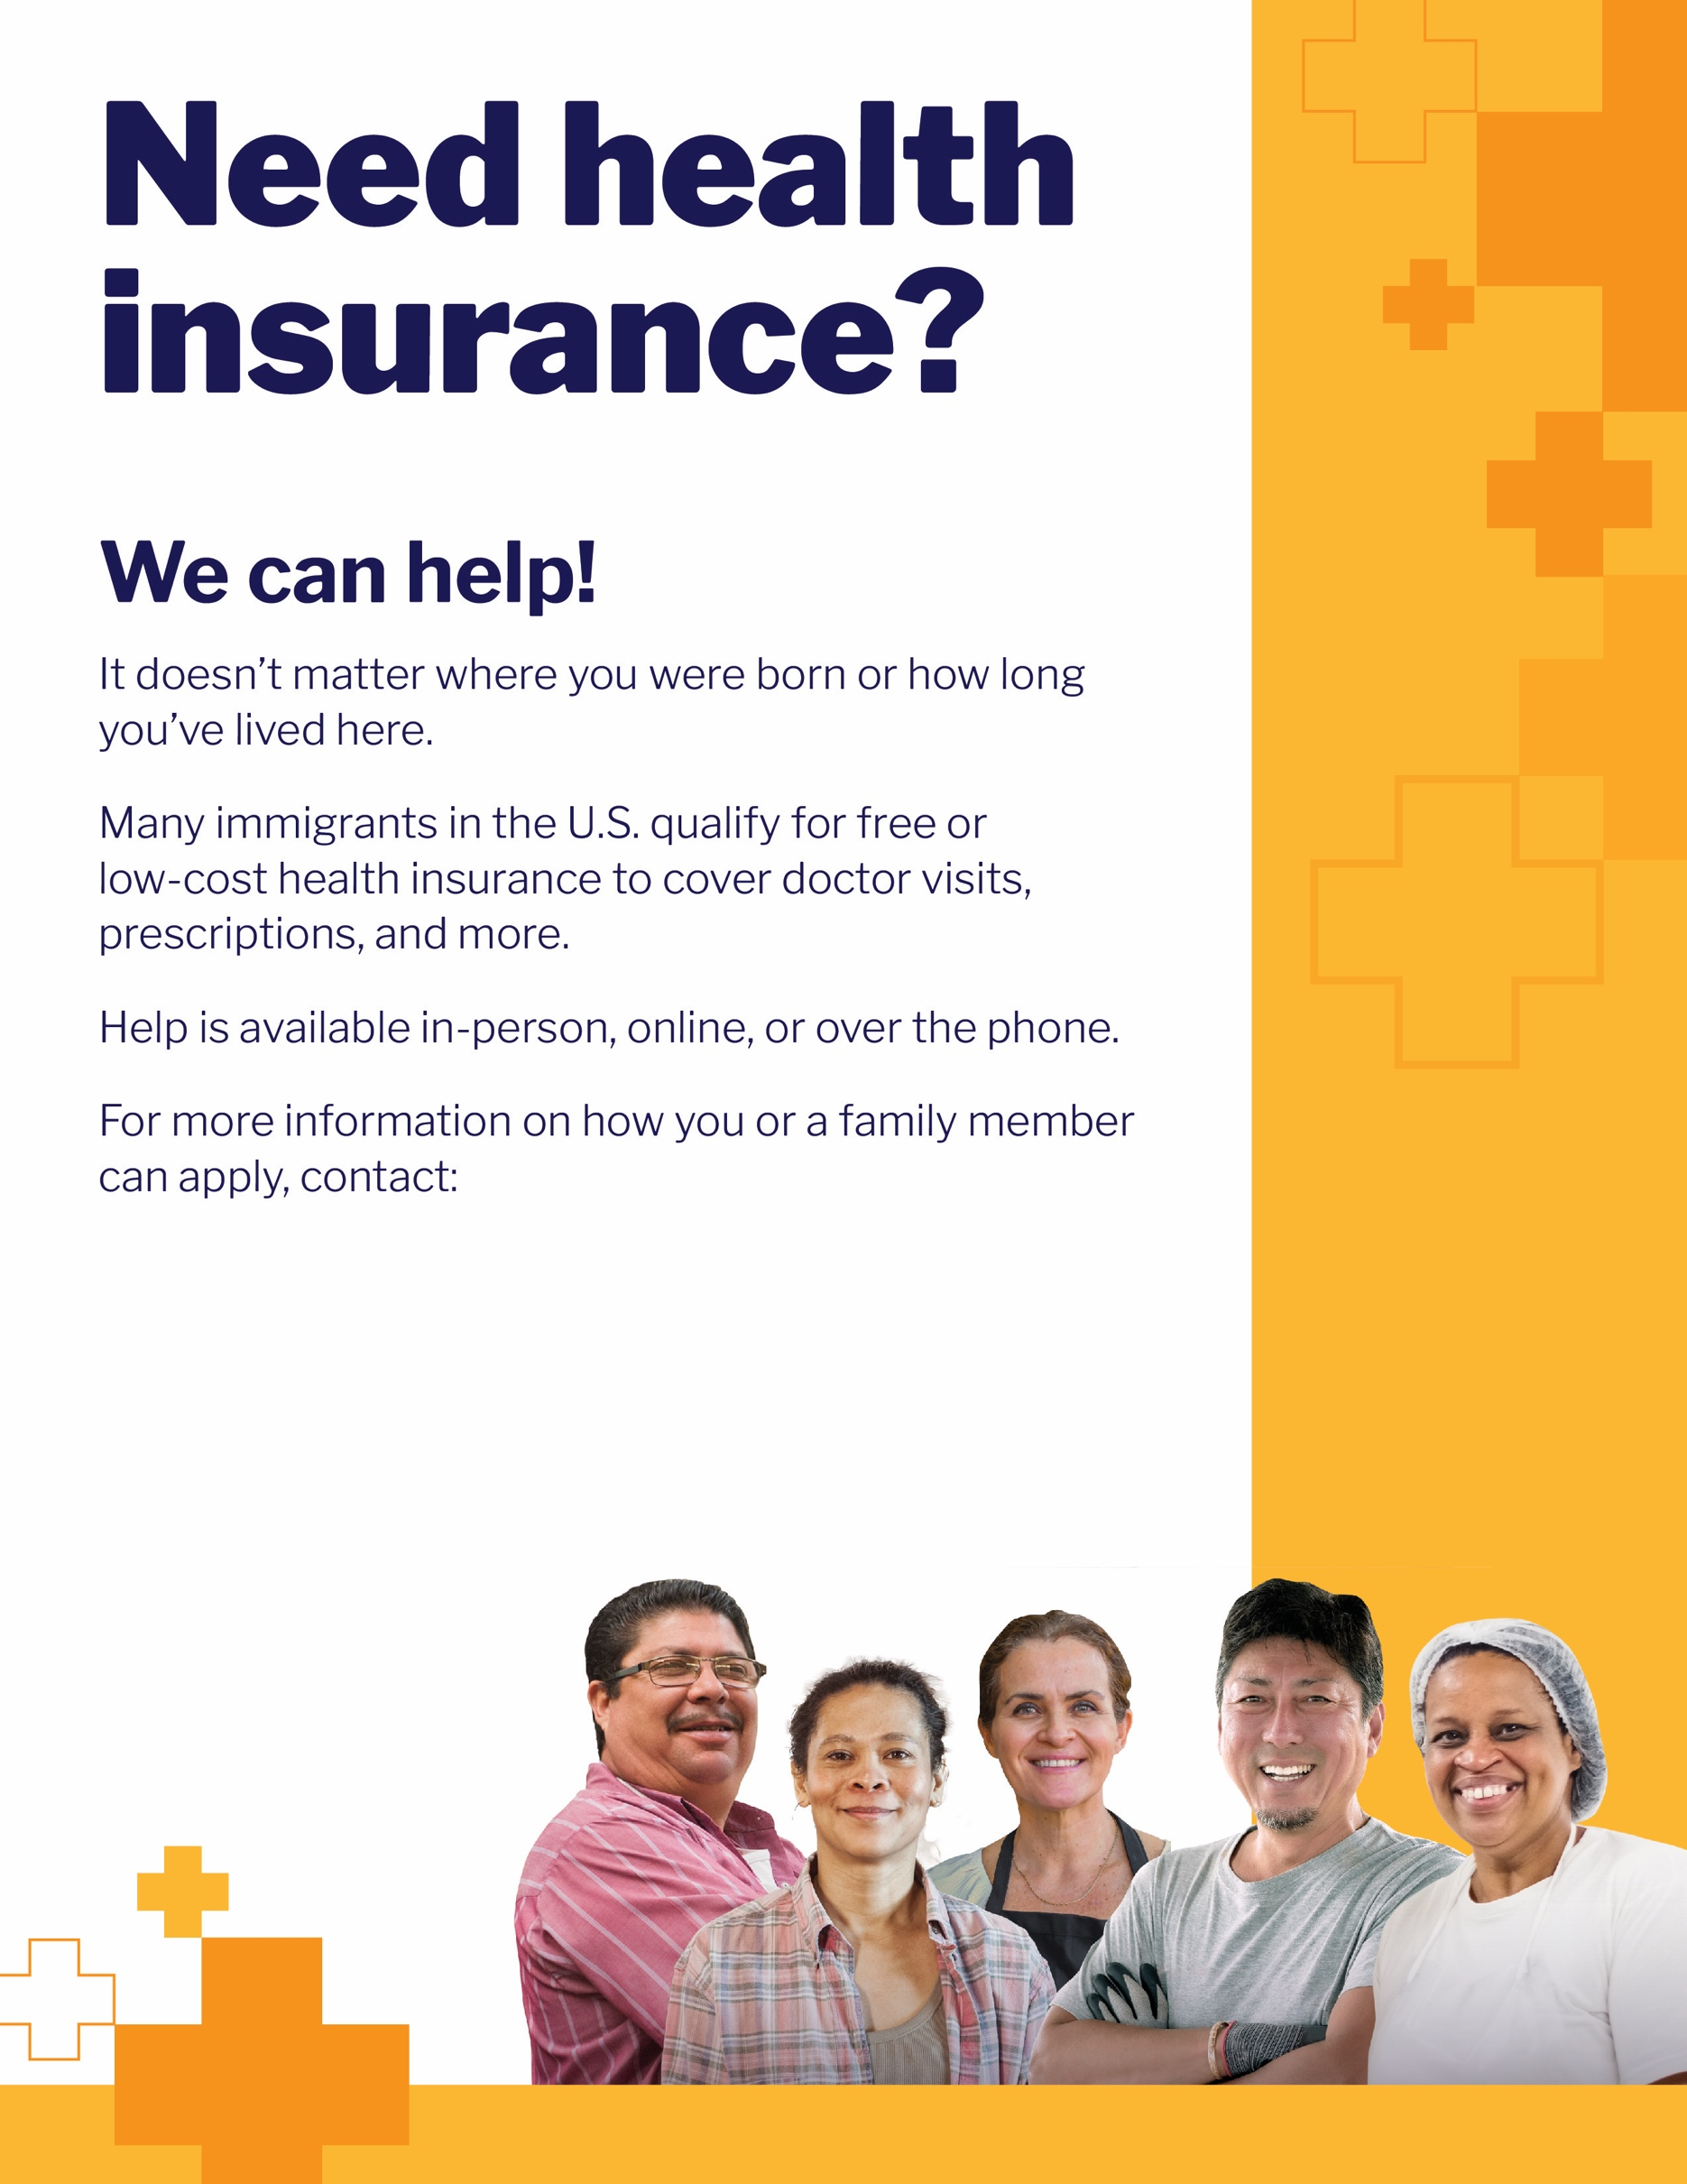

INSERT LOGO HERE
State Program Name
Call (Phone number)
URL

