Open Enrollment 2025 Communications Toolkit
August 2025
As the open enrollment period for plan year 2026 approaches, health insurance Marketplaces face a rapidly shifting policy environment. Three major federal changes–the 2025 Marketplace Integrity and Affordability Rule, the budget reconciliation law (H.R.1), and the scheduled expiration of enhanced premium tax credits–will significantly impact how millions of Americans access and afford health coverage.
These changes will influence the way Marketplaces engage with enrollees, community partners, and stakeholders. For many, that could mean confusion, loss of coverage, or increased financial strain–especially in communities that already face systemic barriers to coverage and care.
This toolkit is designed to help State-Based Marketplaces (SBMs):
- Maintain trust with enrollees and stakeholders.
- Communicate clearly and effectively.
- Prepare enrollees for upcoming changes.
- Help enrollees maintain coverage and access care.
This toolkit includes content that states can customize to reflect their voice and policy context. Whether SBMs are developing outreach materials, training Navigators, or briefing policymakers, this resource offers the language and tools to respond with clarity, empathy, and confidence.

Table of Contents
Messages for Consumers 2
Email Strategy and Template Messages 5
SMS Strategy and Template Messages 7
Social Media Posts and Graphics 9
Newsletter Blurbs 11

Messages for Consumers
The federal actions impacting Marketplaces are complex, overlapping, and nuanced. To support Marketplace consumers effectively, communications should focus on immediate impacts and those taking effect for plan year 2026. Most consumers will face these changes during the upcoming open enrollment period. To ensure consumers and stakeholders are prepared and can take steps to maintain coverage, communications should begin in the months leading up to open enrollment.
This section outlines core messages that can be adapted across channels and are reflected in the templates throughout this toolkit.
Spanish translations will be available in August 2025.

General Messages

Establish the Changes
- The Trump Administration and Congress have set new rules and passed a new law that will impact your health coverage, costs, and care.
- Recent federal actions are bringing major changes that impact health insurance, including [MARKETPLACE]. These changes will impact how you apply for or renew your coverage, how much it costs, and what’s covered. Most [STATERS] will experience these changes during the upcoming open enrollment period, which will run from [November 1, 2025] through [January 15, 2026].
- There are no changes to your 2025 health plan. If you’re currently enrolled, we encourage you to use your benefits. Whether it’s scheduling your free annual wellness visit or addressing a concern you’ve been putting off, now is the time to take charge of your health.
Note: Depending on the status of coverage terminations for Deferred Action for Childhood Arrivals (DACA) recipients in your state, consider segmenting lists (e.g., email)–if feasible–to convey this message to enrollees who can maintain their 2025 coverage.

Position the Marketplace
- [MARKETPLACE] is here to help. We’re here to guide you through the federal changes and help you stay covered in a plan that meets your needs.
- Big changes are coming to health insurance this year. We’re here to help you understand what’s changing and make sure you get the most from your health plan.
- We’re here to help you understand these changes and what they mean for you and your family. Visit [URL] to read about the new federal rules.

Preview Cost Increases
- Following federal changes, we expect health plan costs to go up in 2026.
- Due to federal changes, your monthly premium for a 2026 health plan may increase. To ensure you get the best value from your plan, come back and shop during open enrollment. There may be better options for your needs and budget. In [MONTH], you will be able to preview 2026 plans and prices.
- Even if your current plan costs more next year, you have options. There may be other plans with lower premiums or lower costs when you get care. You will have a chance to explore all plans and prices during open enrollment.
- While some federal savings are ending, most people will still get help paying for their health insurance. We’re here to help you figure out how much you can save.
- Today, [###/MOST] people who get their health insurance through [MARKETPLACE] get extra tax credits to help lower the cost of their monthly premiums. Unless Congress acts to extend them, those extra tax credits will end in December.

Encourage Plan Shopping
- Plans and prices change every year. This year, it’s especially important to review your options. Federal changes may affect your eligibility, plan benefits, and costs.
- You have options. Open enrollment is a chance to think about what you want most out of a health plan, and we can help you find the right match. That might mean changing your current health plan to get the best value.
- Make sure your health plan still works for you. There may be better options for your needs and budget, so take time to compare plans and find coverage that fits.
- Even if you’ve looked before, because of federal changes impacting all health insurance Marketplaces, it’s more important than ever to review your options.
- Starting in [MONTH], you can start to compare 2026 plans and prices. Our [WINDOW-SHOPPING/ESTIMATOR] tool is easy to use and only takes a few minutes to get an estimate. You don’t need an account to use the tool. Visit [URL] to explore your options.

Prepare for Paperwork
- Due to federal changes, some people may need to submit extra paperwork this year. If you get a [NOTICE] asking for documents, don’t wait. Respond quickly to avoid losing coverage.
- Keep an eye on your [MARKETPLACE] account. We will message you if we need documents and provide instructions on how to submit them.
- When you apply for a health plan through [MARKETPLACE], we ask about your household income so we can help you get savings. If you are eligible for savings (called a premium tax credit) to help pay for your plan, we review your income information to make sure you get the right amount of savings. If we can’t confirm your income through data in a previous tax return or other sources, you’ll have 90 days to submit documents like pay stubs, W-2s, 1099s, or your 1040 tax return.

Understand Your Taxes
- If you get an advance premium tax credit–the savings that lower the cost of your monthly premium–you are required to file taxes and a special form (IRS Form 8962) to make sure you receive the right amount of savings based on your income.
- If you received advance premium tax credits for your 2024 health plan, you must file your 2024 tax return and include IRS Form 8962. If you miss this step, you won’t be eligible for premium savings in 2026. Go to [URL] for more information about taxes and your health plan.
- If you haven’t filed your 2024 taxes yet, we encourage you to do it soon. E-filing (filing electronically through a tax preparer or using tax software) can help avoid IRS processing delays.
- It’s more important than ever to update your estimated income during open enrollment. You could owe money back to the IRS if you receive a larger advance premium tax credit than you qualify for. This could happen if you underestimate your income. Due to new federal rules, some people will need to pay back more money than they have in the past.
- If you’re not sure how to estimate your income for next year, or you want to lower your chances of owing money back to the IRS, we can help.
- If you’re worried about owing money to the IRS, you have options. One way to lower that risk is to choose a smaller advance premium tax credit. If it turns out you qualified for more help than you received, you’ll get the rest as a tax refund after you file your taxes the next year. It’s one way to stay covered now and avoid surprises later.

Population-Specific Messages

Immigrant Community
- The Trump Administration and Congress have set new rules and passed a new law that will impact how millions of people get health insurance. These changes will have additional impacts on immigrant communities.
- A new federal law changes who can receive premium tax credits through [MARKETPLACE] based on their immigration status. Some of the changes are happening now, and there will be more changes next year. To understand all the changes that will affect immigrants living in [STATE], visit [URL].
- Starting in 2026, people who are not eligible for [Medicaid] due to their immigration status–and who earn below a certain income level–will no longer qualify for tax credits for private plans through [MARKETPLACE]. For example, this would apply to an individual making up to $15,650 in a year or a household of three making up to $26,650. Immigrants with a higher income may still be eligible for a tax credit.
- Due to changes in federal eligibility rules, DACA recipients are no longer considered eligible for Marketplace coverage. As a result, [MARKETPLACE] coverage for DACA recipients in [STATE] will end by [DATE]. Other options may be available, including through [LOCAL ORGANIZATION].
- While some immigrants are no longer eligible for coverage through [MARKETPLACE], other family members may still qualify. For example, U.S.-born children of immigrants can still get [Medicaid] or private plans with financial help through [MARKETPLACE]. Call [XXX-XXX-XXXX] if you need help understanding your family’s options.

Households With Income Above 400% of the Federal Poverty Level
- The federal government is ending savings for higher-income households. For example, an individual making more than $62,600 or a household of four making more than $120,600 will no longer receive premium tax credits.
- Even if your current plan costs more next year, you have options. There may be other plans with lower premiums or lower costs when you get care. You will have a chance to explore these plans and prices during open enrollment.

Policy-Specific Messages

Gender Affirming Care (If applicable to your state and/or local issuers)
- Under new federal rules, some health plans in [MARKETPLACE] may no longer cover gender affirming care.
- Open enrollment is your chance to explore your plan options and make sure the services you need are covered. Visit [URL] to check which services are covered by each plan. To see if a plan covers gender affirming care, [INSERT WEBSITE-SPECIFIC STEPS].
- We can help you understand your health plan options. Contact our team of trained experts to review your options. Visit [URL] or call [XXX-XXX-XXXX] for free help.

Email Strategy and Template Messages
Health insurance Marketplaces achieved record-breaking enrollment in 2025, covering more lives than ever before. As open enrollment approaches, retaining enrollees will require targeted outreach. To support enrollees in maintaining coverage, SBMs should implement a phased email campaign that delivers timely, relevant, and actionable information in the months leading up to open enrollment.
Prepare Enrollees for Changes  August/Early September | Prime Enrollees to Shop  Early October | Drive Early Action  Late October
- Alert enrollees to upcoming federal changes.  - Direct traffic to updated resources.  - Provide clear steps to prepare. | - Announce 2026 plans and prices.  - Promote window-shopping and estimator tools.  - Encourage plan comparison. | - Raise awareness of open enrollment dates.  - Promote readiness and early shopping.  - Highlight enrollment assistance.

If possible, segment recipients to provide more relevant information. For example:
- Enrollees with DACA status: exclude from emails promoting plan shopping.
- Enrollees with household incomes above 400% FPL: send details about the expiration of tax credits.
- 2024 enrollees who received tax credits: remind them to file their 2024 taxes.
The email templates provided in this toolkit are intended as guidance. Content should be adapted to align with each Marketplace’s voice, cadence, and formatting standards. Email performance can be enhanced through A/B testing of subject lines, inclusion of graphics and buttons, and use of personalization features within customer relationship management (CRM) systems.

Prepare Enrollees for Changes

Subject Line Options
Important: Health Insurance Changes Coming Soon
Get Ready: What’s Changing for 2026 Coverage
Stay Covered: What You Need to Know Before Open Enrollment
Email Body
Big changes are coming to health insurance in 2026.
New federal rules will impact how you apply for or renew your coverage, what’s covered, and how much it costs. Following federal changes, we expect health plan costs to go up in 2026.
While there are no changes to your 2025 health plan, it’s important to start preparing now.
How to get ready:
- See what’s changing: visit [URL] for a summary of federal changes and what they mean for you.
- File your 2024 taxes if you haven’t yet: if you received tax credits for your 2024 health plan, you must file your 2024 tax return and include IRS Form 8962. If you miss this step, you won’t be eligible for premium savings in 2026.
- Watch for notices: some people may need to submit additional documents this year.
We’re here to help you understand what’s changing and stay covered.
Most changes will take effect during open enrollment, which runs from [November 1, 2025, to January 15, 2026]. This is your opportunity to explore your options and choose the plan that best fits your needs and budget.
Button: Learn More About the Changes

Prime Enrollees to Shop

Subject Line Options
Preview 2026 Health Plans and Prices Today
2026 Health Plans Are Here—Start Comparing Now
See What’s New: Health Plans and Prices for 2026
Email Body
New health plans and prices for 2026 are now available.
Due to recent federal changes, some plans may cost more or offer different benefits than last year. Start exploring your options today so you can get the most out of your 2026 health plan.
Use our [ESTIMATOR OR WINDOW-SHOPPING TOOL].
- Compare plans and prices: you may find another plan works better for your health needs and budget.
- Check eligibility for savings: many will still qualify for health insurance financial assistance, even with some federal savings ending.
Button: Compare Plans Now
Open enrollment is your chance to select a plan that fits your needs and budget. Start exploring your options today. Open enrollment runs from [November 1, 2025, to January 15, 2026].
Need help?
Free assistance is available. We’re here to help you understand your options. Visit [URL] or call [XXX-XXX-XXXX] to speak with a trained expert.

Drive Early Action

Subject Line Options
Open Enrollment Starts Soon—Get Ready to Shop
Open Enrollment Starts Soon: Are You Ready?
Need Health Insurance for 2026? Act Now
Email Body
Open enrollment for 2026 health plans starts [November 1].
This year, federal changes may affect plan costs and benefits, making it more important than ever to explore your options now.
Why shop early?
- There are new plans and prices. Take the time to see how you can get the most value out of your plan.
- Get free enrollment assistance before the deadline rush.
- Avoid delays in coverage or care. Shopping early gives you time to provide any additional documents needed this year.
Make sure your health plan still works for you. There may be better options for your needs and budget, so take time to compare plans and find coverage that fits.
Button: Compare Plans Now
Need help?
That’s what we’re here for. Our trained experts can help you compare plans and get savings. Visit [URL] or call [XXX-XXX-XXXX] to get started.

SMS Strategy and Template Messages
Text messaging is a powerful tool for reaching enrollees with timely, actionable information. SMS can help reinforce key messages, drive traffic to resources, and prompt early action. SMS campaigns should complement other direct-to-consumer communications, such as email or direct mail. Consider these best practices when preparing an SMS campaign:
- Limit messages to 160 characters to ensure full delivery across all devices. Keep in mind that translated messages may require more characters.
- Include shortened URLs to direct users to more information or tools.
- Send messages at appropriate times (e.g., mid-morning or early evening) to increase engagement.
For additional SMS guidance, refer to the State Health and Value Strategies Optimizing SMS Strategies expert perspective.

Prepare Enrollees for Changes
Have you heard about federal changes to health insurance? [MARKETPLACE] is here to help you understand what’s changing. Visit [URL]
Big changes are coming to health insurance. [MARKETPLACE] is here to help you understand what’s new and stay covered. Visit [URL]
Federal changes are increasing health plan costs in 2026. [MARKETPLACE] is here to help you get the most out of your plan. See what’s changing: [URL]

Prime Enrollees to Shop
2026 health plans and prices are now available. Compare [MARKETPLACE] options today: [SHORT URL]
Use the [MARKETPLACE] [ESTIMATOR] tool to preview 2026 plans and prices–no login needed: [SHORT URL]
Health plans and prices change every year. Start exploring [MARKETPLACE] to find the best fit: [SHORT URL]

Drive Early Action
Open enrollment through [MARKETPLACE] starts [Nov. 1]! Be ready to shop early: [SHORT URL]
Need help enrolling through [MARKETPLACE]? Free assistance is available. Call [XXX-XXX-XXXX] or visit [SHORT URL]
Don’t wait—enroll early to avoid delays in health coverage: [SHORT URL]

Social Media Posts and Graphics
Social media is a critical channel for reaching a broad audience with timely, accessible information. The following sample posts and graphics are designed to help SBMs communicate key federal updates. These posts can complement branded content that provides more state-specific details or support.
The following template communications resources in English and Spanish are available for download through the State Health and Value Strategies Social Press Kit.
Graphic | Post Copy
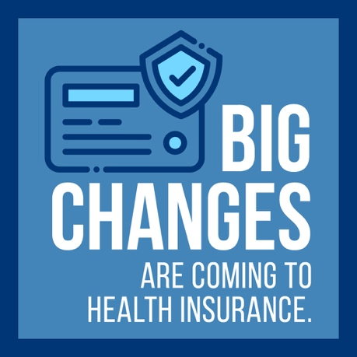 | New federal rules will change how you apply for health insurance, what’s covered, and what it costs in 2026. [MARKETPLACE] is here to help you stay informed and covered. See what’s changing: [URL]
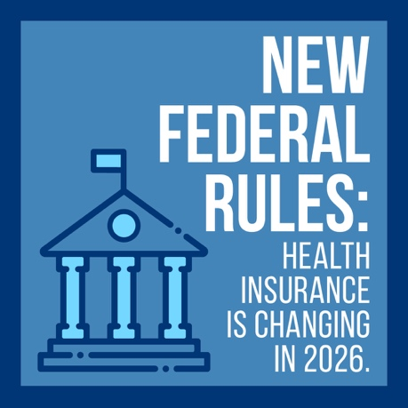 | New federal laws are changing health insurance in 2026. [MARKETPLACE] is here to guide you through what’s new. Visit [URL] to learn more.
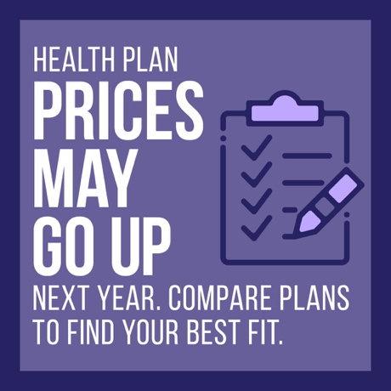 | Some federal savings are ending, and prices may go up next year. But you still have options. Compare plans and find what fits your budget during open enrollment starting Nov. 1. Get an estimate today: [URL]
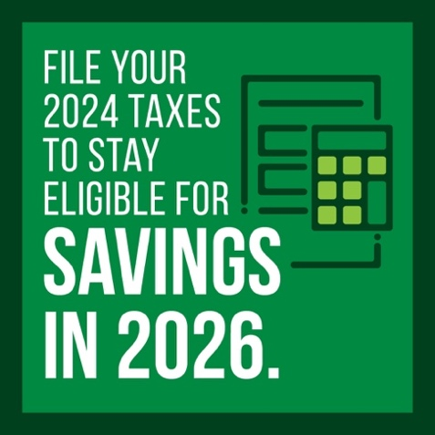 | Did you get savings in 2024? Filing your 2024 taxes is the only way to stay eligible for tax credits through [MARKETPLACE] in 2026. Visit [URL] to get help with keeping your health insurance savings.
 | Haven’t filed your 2024 taxes yet? Do it soon to stay eligible for premium savings in 2026. E-filing can help avoid IRS processing delays.
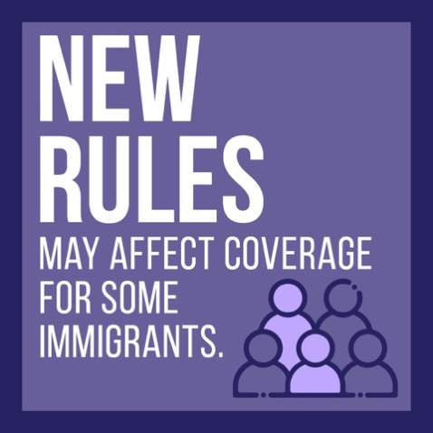 | New federal rules will impact who qualifies for tax credits through [MARKETPLACE]. Some immigrants, including DACA recipients, will be affected. We’re here to help you understand what these changes mean for you and your family. Visit [URL] or call [XXX-XXX-XXXX] for free help.
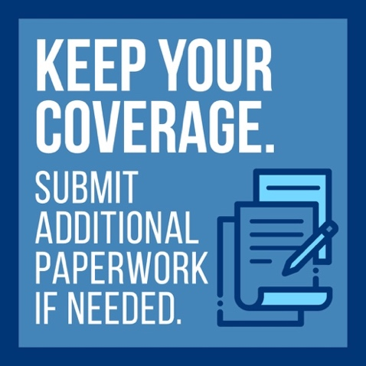 | Keep an eye on your [MARKETPLACE] account. We’ll reach out if we need documents like pay stubs or tax forms to keep you insured. Respond quickly to avoid health coverage gaps.

Newsletter Blurbs
The following newsletter blurbs are designed for partners to share on behalf of the Marketplace in their state. This language can be used in email newsletters, community bulletins, or organizational updates to help inform stakeholders and prepare consumers ahead of open enrollment. Partners should be encouraged to customize the language to match their audience and communication style while reinforcing the Marketplace’s role as a trusted source of information and support.
Federal Changes May Impact Health Coverage
New federal rules will affect health coverage, costs, and care. [MARKETPLACE] is prepared to help [STATERS] navigate the changes and maintain their coverage. With open enrollment just around the corner, now’s the time to learn about the changes and explore your options. Visit [URL].
Health Plan Costs Expected to Rise
Due to federal policy changes, health plans may cost more in 2026. While some financial assistance will remain available, many people could see higher monthly premiums. [MARKETPLACE] is helping [STATERS] understand the new rules and explore their options. Visit [URL] to explore 2026 plans and prices.
Changes to Immigrant Eligibility
New federal rules will affect health insurance eligibility for some immigrants starting in 2026. Certain individuals who previously qualified for financial help through [MARKETPLACE] may no longer be eligible. However, other family members may still qualify. [MARKETPLACE] is committed to helping [STATERS] understand the new rules and their 2026 health plan options. Visit [URL] for free enrollment assistance.
Coverage for Gender Affirming Care May Change
Under new federal rules, some health plans may no longer cover gender affirming care. Open enrollment through [MARKETPLACE] is an important time for individuals to review plan details and ensure the services they need are covered. [MARKETPLACE] offers free assistance to help find the right plan: [URL]

Support for this toolkit was provided by the Robert Wood Johnson Foundation. The views expressed here do not necessarily reflect the views of the Foundation.
ABOUT THE ROBERT WOOD JOHNSON FOUNDATION
The Robert Wood Johnson Foundation (RWJF) is a leading national philanthropy dedicated to taking bold leaps to transform health in our lifetime. Through funding, convening, advocacy, and evidence-building, we work side-by-side with communities, practitioners, and institutions to get to health equity faster and pave the way together to a future where health is no longer a privilege, but a right.
RWJF believes that achieving strong, lasting connections across the healthcare, public health, and social services systems helps build healthier and more equitable communities that provide everyone a fair and just opportunity for health and wellbeing.
ABOUT STATE HEALTH AND VALUE STRATEGIES—PRINCETON UNIVERSITY SCHOOL OF PUBLIC AND INTERNATIONAL AFFAIRS
State Health and Value Strategies (SHVS) assists states in their efforts to transform health and healthcare by providing targeted technical assistance to state officials and agencies. The program is a grantee of the Robert Wood Johnson Foundation, led by staff at Princeton University’s School of Public and International Affairs. The program connects states with experts and peers to undertake healthcare transformation initiatives. By engaging state officials, the program provides lessons learned, highlights successful strategies, and brings together states with experts in the field. Learn more at www.shvs.org.

ABOUT GMMB
This toolkit was prepared by GMMB. GMMB is a full-service communications firm dedicated to creating real and lasting positive change in the world. We work on behalf of several of the world’s largest foundations, leading public interest groups and trade associations, federal and state government agencies, and corporations. For more than 40 years, we have been on the front line of issue-based communications, earning a reputation for shaping public opinion by developing research-based communications strategies that achieve real results. For more information, visit www.gmmb.com.

